AQ1:
#include <stdio.h>
#include <stdbool.h>
#include <stdlib.h>

bool containsDuplicate(int* nums, int numsSize) {
int hashSize = numsSize * 2;
int* hash = (int*)calloc(hashSize, sizeof(int));

for (int i = 0; i < numsSize; i++) {
int key = abs(nums[i]) % hashSize;

if (hash[key] == nums[i]) { // Found duplicate
free(hash);
return true;
}
hash[key] = nums[i];
}

free(hash);
return false;
}

int main() {
int nums[] = {1, 2, 3, 1};
int size = sizeof(nums) / sizeof(nums[0]);

// Print the array initially
printf("Array: ");
for (int i = 0; i < size; i++) {
printf("%d ", nums[i]);
}
printf("\n");

// Check duplicate
if (containsDuplicate(nums, size))
printf("Contains duplicate: true");
else
printf("Contains duplicate: false");

return 0;
}

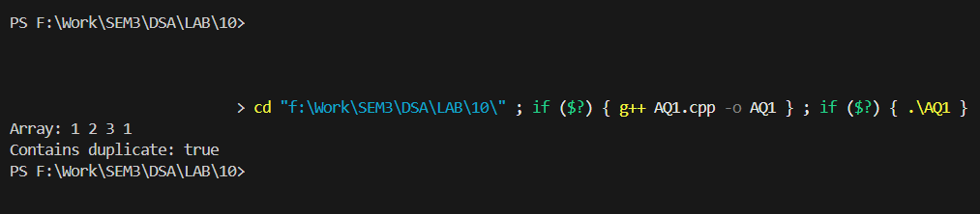
Output:

AQ2:
#include <stdio.h>
#include <stdlib.h>

int main() {
int A[] = {1, 2, 3, 4};
int B[] = {3, 4, 5, 6};
int sizeA = sizeof(A) / sizeof(A[0]);
int sizeB = sizeof(B) / sizeof(B[0]);

// Print both arrays initially
printf("Array A: ");
for (int i = 0; i < sizeA; i++) printf("%d ", A[i]);
printf("\nArray B: ");
for (int i = 0; i < sizeB; i++) printf("%d ", B[i]);
printf("\n");

int hashSize = sizeA + sizeB;
int *hash = (int *)calloc(hashSize, sizeof(int));

for (int i = 0; i < sizeA; i++) {
int key = abs(A[i]) % hashSize;
hash[key] = A[i];
}

printf("Common Elements: ");
int found = 0;
for (int i = 0; i < sizeB; i++) {
int key = abs(B[i]) % hashSize;
if (hash[key] == B[i]) {
printf("%d ", B[i]);
found = 1;
}
}

if (!found)
printf("None");

free(hash);
return 0;
}

Output: 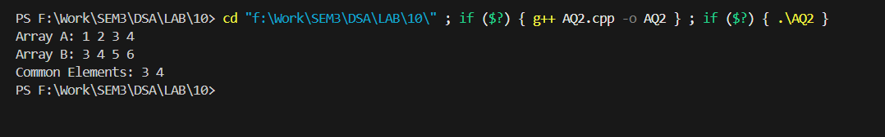
AQ3:
#include <stdio.h>
#include <stdlib.h>

int main() {
int nums[] = {2, 3, 2, 4, 3, 2};
int size = sizeof(nums) / sizeof(nums[0]);

// Print array initially
printf("Array: ");
for (int i = 0; i < size; i++)
printf("%d ", nums[i]);
printf("\n");

// Hash table (key = number, value = count)
int hashSize = size * 2;
int *hashKey = (int *)calloc(hashSize, sizeof(int));
int *hashVal = (int *)calloc(hashSize, sizeof(int));

// Insert and count frequency
for (int i = 0; i < size; i++) {
int key = abs(nums[i]) % hashSize;

// If same number already at hashed index → increment count
if (hashKey[key] == nums[i]) {
hashVal[key]++;
}
else { // store new number + set count to 1
hashKey[key] = nums[i];
hashVal[key] = 1;
}
}

// Print frequency result
printf("\nFrequency of each element:\n");
for (int i = 0; i < hashSize; i++) {
if (hashVal[i] > 0) {
printf("%d : %d times\n", hashKey[i], hashVal[i]);
}
}

free(hashKey);
free(hashVal);
return 0;
}

Output:
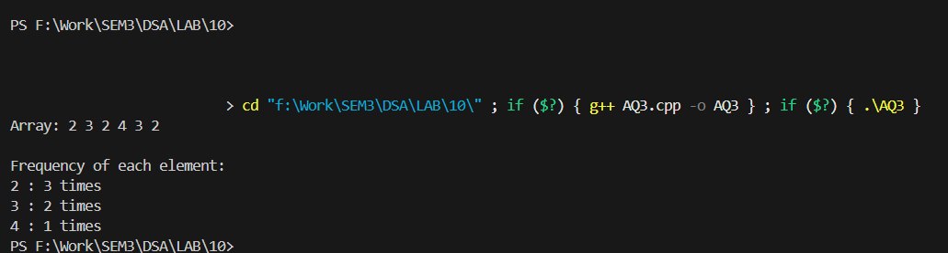
AQ4:
#include <stdio.h>
#include <stdlib.h>

int main() {
int nums[] = {4, 5, 1, 2, 0, 4};
int size = sizeof(nums) / sizeof(nums[0]);

// Print array initially
printf("Array: ");
for (int i = 0; i < size; i++)
printf("%d ", nums[i]);
printf("\n");

int hashSize = size * 2;
int *hashKey = (int *)calloc(hashSize, sizeof(int));
int *hashVal = (int *)calloc(hashSize, sizeof(int));

for (int i = 0; i < size; i++) {
int key = abs(nums[i]) % hashSize;
if (hashKey[key] == nums[i]) {
hashVal[key]++;
} else {
hashKey[key] = nums[i];
hashVal[key] = 1;
}
}

int found = 0;
for (int i = 0; i < size; i++) {
int key = abs(nums[i]) % hashSize;
if (hashVal[key] == 1) {
printf("\nFirst non-repeating element: %d\n", nums[i]);
found = 1;
break;
}
}

if (!found)
printf("\nNo non-repeating element found\n");

free(hashKey);
free(hashVal);
return 0;
}

Output:
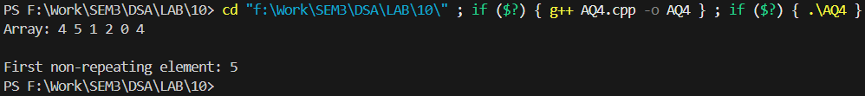
AQ5:
#include <stdio.h>
#include <stdlib.h>
#include <stdbool.h>

struct Node {
int data;
struct Node *next;
};
bool hasCycle(struct Node *head) {
struct Node **visited = (struct Node **)calloc(100, sizeof(struct Node *));
int size = 100;

while (head != NULL) {
int key = ((unsigned long)head) % size;

if (visited[key] == head) {
free(visited);
return true;
}

visited[key] = head;
head = head->next;
}

free(visited);
return false;
}
int main() {
// Creating linked list: 1 → 2 → 3 → 4 → 2
struct Node *n1 = (struct Node *)malloc(sizeof(struct Node));
struct Node *n2 = (struct Node *)malloc(sizeof(struct Node));
struct Node *n3 = (struct Node *)malloc(sizeof(struct Node));
struct Node *n4 = (struct Node *)malloc(sizeof(struct Node));
n1->data = 1; n1->next = n2;
n2->data = 2; n2->next = n3;
n3->data = 3; n3->next = n4;
n4->data = 4; n4->next = n2; // Loop back to node 2
// Check loop
if (hasCycle(n1))
printf("true\n");
else
printf("false\n");

return 0;
}
Output:
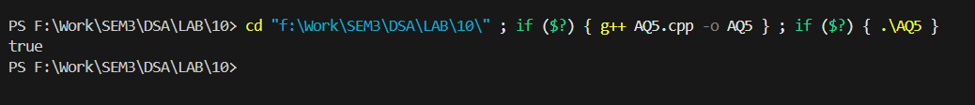
AQ6:
#include <stdio.h>
#include <stdlib.h>
#include <stdbool.h>

struct Node {
int data;
struct Node *left, *right;
};

#define HASH_SIZE 100
int hashSet[HASH_SIZE] = {0};
int hashVal[HASH_SIZE] = {0};

bool checkDuplicate(struct Node *root) {
if (root == NULL)
return false;

int key = abs(root->data) % HASH_SIZE;

if (hashSet[key] == root->data && hashVal[key] == 1)
return true;

hashSet[key] = root->data;
hashVal[key] = 1;

if (checkDuplicate(root->left)) return true;
if (checkDuplicate(root->right)) return true;

return false;
}

// Create new node
struct Node *newNode(int data) {
struct Node *node = (struct Node *)malloc(sizeof(struct Node));
node->data = data;
node->left = node->right = NULL;
return node;
}

int main() {

struct Node *root = newNode(5);
root->left = newNode(3);
root->right = newNode(8);
root->left->left = newNode(2);
root->left->right = newNode(3);
root->right->right = newNode(9);

if (checkDuplicate(root))
printf("Duplicates Found\n");
else
printf("No Duplicates\n");

return 0;
}

Output:
